PROJECT DEVELOPMENT PHASE SPRINT 1

|  |  |
| --- | --- |
| Date | 30 October 2022 |
| Team ID | PNT2022TMID53476 |
| Project Name | Visualizing and Predicting Heart Diseases with  an Interactive Dash Board |

SOURCE CODE:

It is with the understanding of the given set if dataset and fetching the data and cleaning the data with the dataset.

These are the results for the dataset provided:

# Heart Disease Prediction CSV file:

* + To fetch the dataset



* + To view the data

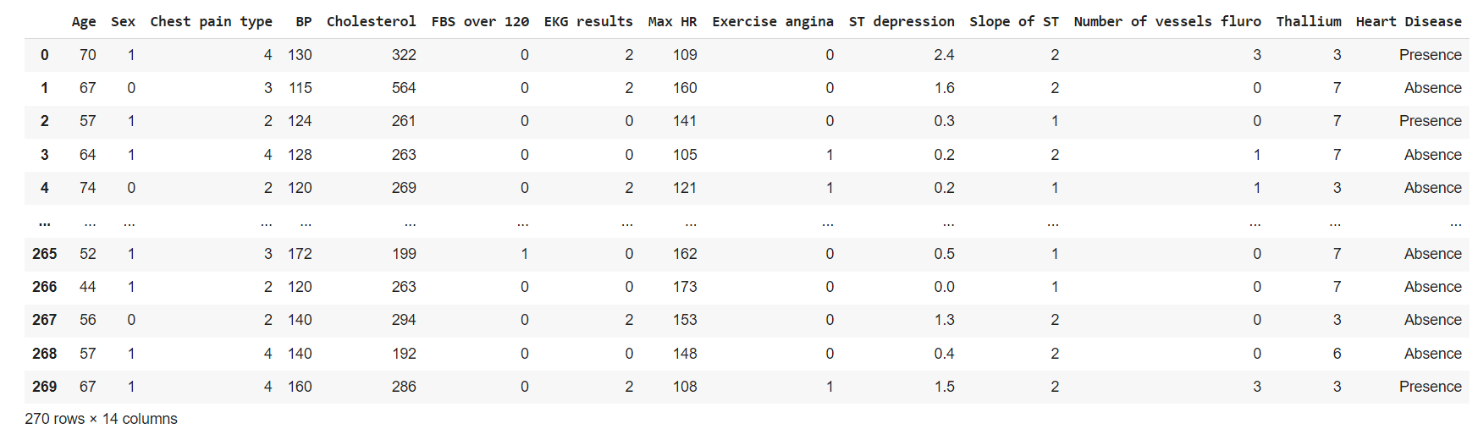

* + To view the various datatypes of the respected columns given in the dataset

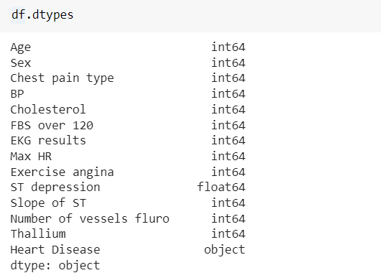

* + To describe the information of the dataset that is fetched.

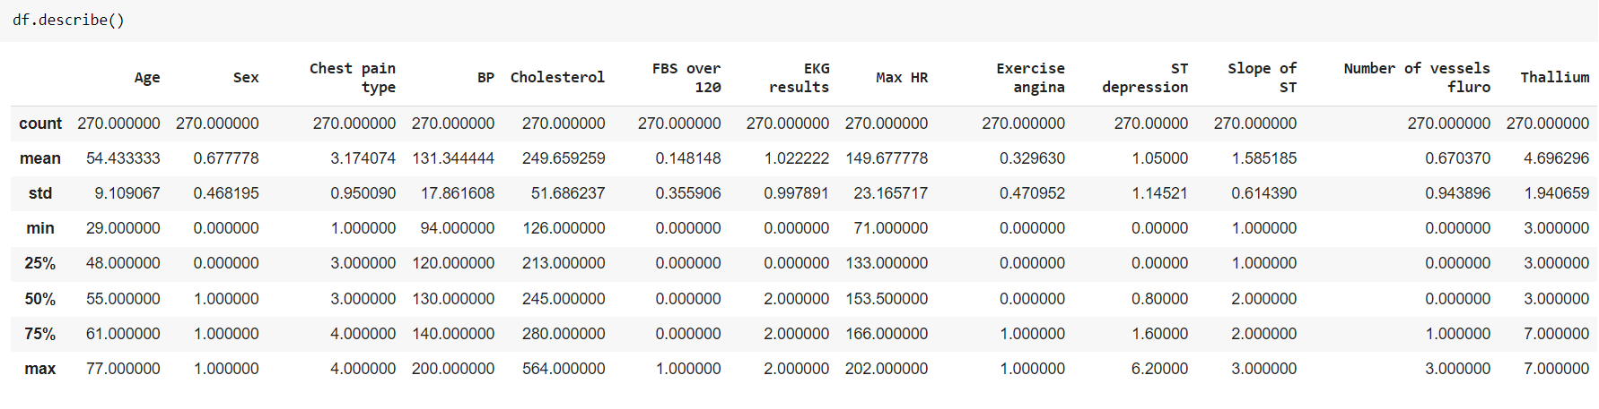

* + To check the null values if present:

